Adapt It Tutorial – Part 1 Basic Procedures
Bruce Waters
SIL Australia; email: bruce_waters@sil.org
October 2002, Revised March 2011

This tutorial will take you through the basic procedures for using Adapt It to adapt some "source language" text into another language, which we call the "target language". The "source language" is the language you are going to adapt from – for this tutorial we will use a few verses from the Melanesian Tok Pisin translation of 1 John. The "target language" is the language you are going to adapt into – for this tutorial it will be English. You do not need to understand Tok Pisin to be able to work successfully through this tutorial; you will be told what adaptations to make for each Tok Pisin word or phrase, or you can make arbitrary translations of your own if you wish.

Because second language speakers of English might be using this tutorial, some explanations might be more simple and basic than you would expect. Please be patient, others might not know computers as well as you do, or not be familiar with Windows operations that you already know well.

This tutorial assumes you are going to use the Unicode version of Adapt It, and the screen shots will reflect version 6. It also assumes you have not run Adapt It yet. The tutorial applies equally well if you run the Regular (non-Unicode) version of Adapt It. Only a small subset of Adapt It's features are covered here – just the basics to get you started.

If you have already run Adapt It and created a project, or even a document, you will probably want to skip the first part of the tutorial, and start by making a new project with the source language name "Tok Pisin", and the target language name "English"; then create a new document – selecting the file "Tok Pisin fragment 1 John.txt", and supply an output filename of your choice when prompted. Then jump to "Chapter 2 Working on a document" and start following the instructions there. The file "Tok Pisin fragment 1 John.txt" is included in every distributed version of Adapt It, you will find it in the Adapt It WX Unicode folder in Program Files on a Windows machine, or the Adapt It WX folder in Program Files if you have instead installed the Regular version. (Adapt It is available for Linux and Macintosh too, but only the Unicode version.)

If you have never used Adapt It, start at Chapter 1 Getting started. We assume that Adapt It has been installed on your machine beforehand. If not, open the document "Adapt It Quick Start" and follow the instructions at the section titled “Launching Adapt It for the first time”, to get the application ready for use. (A link to the Quick Start html document is in the Adapt It WX Unicode group on the Windows Start menu. The wizard has more pages in version 6, but you can just accept the defaults.) Then return to this tutorial file and begin at Chapter 1 below. The WX in the Adapt It WX name refers to wxWidgets – a cross platform development suite which allows us to build Adapt It for Windows, Linux and Macintosh from a single code base. In what follows we will drop the “WX Unicode” from the name, to save space.

Chapter 1 Getting started

Step | How to do it | What happens when you do it
- Launch Adapt It | - double-click the Adapt It icon, or  - use the Start button, navigate to the Adapt It item in the Programs menu, and then double-click it. | Adapt It will open. It will show a "Welcome to Adapt It" window.  Adapt It will create certain folders on the hard drive. All files associated with the application will be found in a folder called "Adapt It Unicode Work", created in your "My Documents" folder. Adapt It will create other folders within the work folder when you create a project, and create documents within that project.
- Get rid of the welcome window. | - click the OK button in the welcome window | The window will disappear. The Start Working wizard's window will then appear, so you can create a project and create your first adaptation document.

1.1 The Start Working wizard

You will now be looking at the first page of the Start Working wizard. It will take you through the steps needed to create a project, set up fonts and colours for the different kinds of information Adapt It knows about, and then to create and open your first document for doing adaptation work. The wizard's first page looks like the following picture, except that the only item in the list box will be <New Project>:

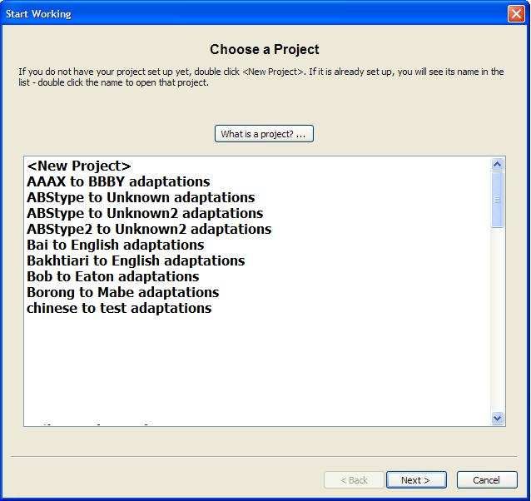

Notice there is a button at the top called "What is a project? …". If you would like to read some information about Adapt It projects, click the button and a window with an explanation of projects will appear. When you have finished reading, click the OK button and the window will disappear.

All of the work you do in translating text from a certain source language to a certain target language must be done within a project dedicated to that language pair, so you must create a project in order to be able to do any useful work. That is the next step.

Step | How to do it | What happens when you do it
- Create a new project | - click once to select the <New Project> item, and then  - click the Next> button. Or instead  - double-click the <New Project> button. | Adapt It will close this page and show you the next page of the wizard. That page lets you tell Adapt It the names of the source and target languages. Adapt It will use these two names to make a name for the new project you are creating.

The second page of the wizard looks like the following picture:

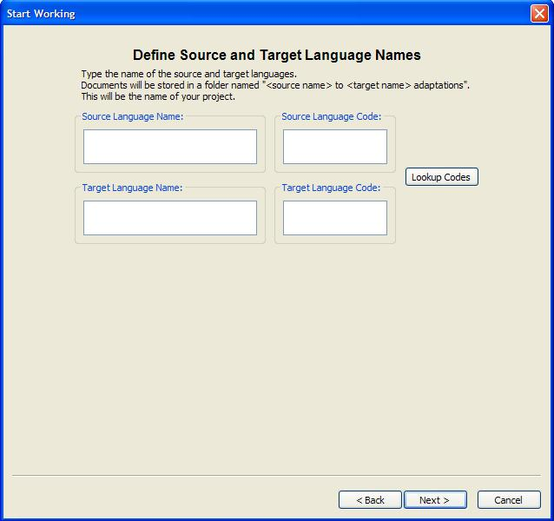

Step | How to do it | What happens when you do it
- Name your new project, and specify the correct language codes for the two languages | - in the Source edit box type the name of the source language; so type Tok Pisin  - in the Target edit box type the name of the target language; so type English  - Type the correct language codes in the boxes, the code for English is en so type en in the Target Language Code box. If you don't know the right code, use the Lookup Codes button. Use it to look up the code for Tok Pisin – see the picture below – the code is tpi – enter it in the language codes dialog, or type it into the wizard's Source Language Code box after you return to the wizard.  - click the Next> button | Adapt It will create the name "Tok Pisin to English adaptations" as your new project name, and create a folder with that name in the Adapt It Work folder. Your knowledge base will later be stored in this project folder, and also any documents in a subfolder called "Adaptations".  Make sure you never change any of these folder names that Adapt It creates for you.  (The language codes, such as en and tpi in this tutorial example, are used internally by Adapt It in certain kinds of exports of the adapted text. Other software that reads those exported data files will expect the correct codes to be present.)  Project settings are stored in a text file called AI-ProjectConfiguration.aic

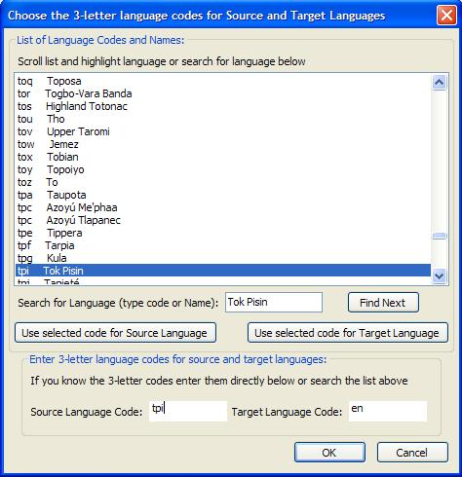

The next page of the wizard allows you to set up a font for your source text, another or the same font for the target text, and a third font (if you wish) for navigation text. Navigation text is verse and chapter numbers, and the names of Unified Standard Format Markers (USFM).

(Skip this paragraph if you know what USFM markup is. These markers are often called "backslash markers" – things like \v used for a verse number, \p for a paragraph break, \c for a chapter number, \s for a subtitle, and so forth. There are are nearly 300 different ones, but usually the source text will make use of only a few dozen different ones. USFM is a document markup standard maintained by the United Bible Societies. These markers will be embedded in the source text that you load into Adapt It, don't try to edit them out – they are actually useful. However, if the data you want to load doesn't have any of these markers, Adapt It will still accept the data and work reasonably well with it.)

Adapt It handles USFM markers automatically. It hides them from you when you work on your adaptation, and it puts them back for you automatically when you Export… the document as a text file which can be read by any word processor application, or third party software like Paratext or Bible Edit or Translation Editor.

The fonts page is shown below. (Note: only the Unicode version of Adapt It will show the 3 checkboxes for text direction; the Regular version of Adapt It can only work with language scripts which read from left to right, and so those checkboxes are not needed in the Regular version. There are only a few small differences between the Regular and Unicode versions' user interface, and these 3 checkboxes is one of them.

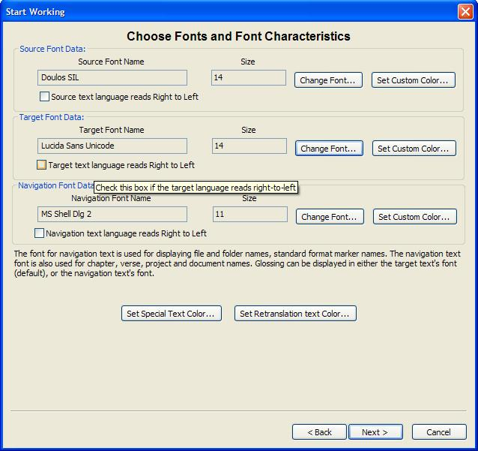

Each button opens another dialog. The Change… buttons open standard font dialogs that let you choose a font, a font size, and to choose one from a few basic colours. The other buttons open standard colour selection dialogs – these buttons allow you to choose any colour you like. It is a good idea to make use of different colours, it helps you not to get confused about which text is source text, which is target text, and which is navigation text. "Special" text is any text which is not part of the actual inspired scriptures, such as subtitles, book titles, file identification information, references, and so forth. Retranslation text is anything which you retranslate, instead of adapting. Navigation text is text shown above the source text line in the main window, such as chapter and verse numbers, and the names of standard format markers; the navigation text's font is also used for many of the dialogs where you need to to type a language name or filename etc. A good size of text to work with is 12 point or larger (navigation text can be smaller, to keep it unobtrusive), and colours show up best if the text is bold, so we will do those things now.

Step | How to do it | What happens when you do it
- Set the source text font, size and colour. | - click the top Change… button | A font dialog will open. Use it to choose the font, size, and colour. (We assume that doing these things is familiar to you, or easy once you see the dialog, so we will not go through the steps here.) Blue is a good choice for the source colour.
- Set the target text font, size and colour. | - click the lower Change… button | A font dialog will open. Use it to choose the font, size, and colour. Maroon or black is a good choice for the target text colour.
- Set the navigation text font, size and colour. | - click the Change Navigation Font… button | A font dialog will open. Use it to choose the font, size, and colour. Use a colour very different from the source or target text colours; 10 or 11 point size is a good choice; a very distinctive font such as Tempus Sans ITC gives a nice appearance, but anything you like is okay.
- Choose colours for the special text and the retranslation text | - click the Set Special Text Color… button  - click any of the colours on the left, or drag the markers in the spectrum of colours at the top right until you get the exact colour you want  - repeat the above two steps, but click the Set Retranslation Text Color… button instead  - (optional step) you can click the Set Color of Navigation Text… button, if you were not able to get the exact colour you wanted for the navigation text when you clicked the Change Navigation Font… button  - click the Next> button to go to the next page of the wizard | You can use any colours you like. Or you can use the one colour, or black, for everything. Adapt It's behaviour does not depend in any way on your colour choices. The ability to use different colours is there only to make it easier for you when you are working on a document.  You can click the <Back button to go back to an earlier page in the wizard, or the Cancel button if you want to exit the wizard.  To reenter the wizard at any time, click the Start Working item on the File menu. Most of the wizard pages are also available from the Preferences... dialog on the Edit menu. You can change fonts or colours or size any time you like while working on a document.

There are a few more wizard pages which you will be shown when you are creating a project. The next one is important. The source and target languages may use the same punctuation characters, or have slightly different ones, or even radically different ones. The punctuation correspondences wizard page lets you set up appropriate correpondences between the source language punctuation set and that for the target language. Adapt It tries to handle inserting punctuation for you automatically, and to do that properly it needs to know what the correspondences are. The default is to show you the Latin punctuation characters for both languages – from that you can change them as necessary – adding, removing and / or changing what is shown. If the source or target language has a punctuation character with no equivalent in the other language, just leave the other language's box empty for that particular correspondence.

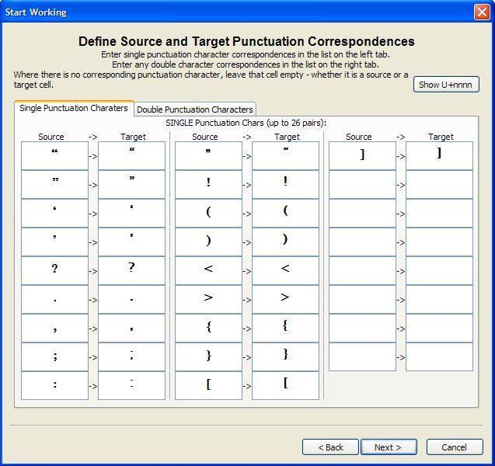

The picture above shows the actual characters. If you prefer to enter UFT-16 Unicode numbers, (4 hexadecimal digits for each number), click the Show U+nnnn button at the top right, and you can add, change or remove as before, but using the number reprentation for each character. (Hexadecimal uses the digits 0 to 9, and for 10 to 15 it uses a, b, c, d, e and f. So there are 16 different digits that can be used for writing hexadecimal numbers.)

The same characters as shown above, look like this after the button is pressed:

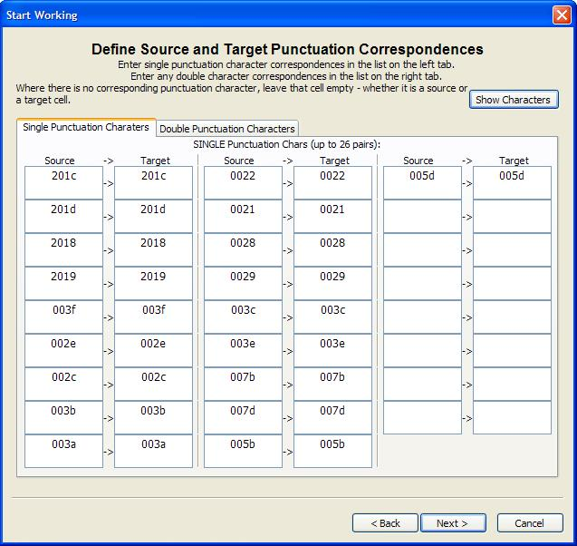
The next page is important if you want to use the “Automatic Capitalization” feature. The page just shows a checkbox initially. If you click it you'll see a second checkbox “Check here if you want Adapt It to automatically distinguish between upper and lower case”. If you want automatic capitalization, you should click the box. You'll then see the full dialog (pictured below) – with default English lower and upper case equivalences shown. You can add to, change, or remove any correpondences no appropriate for the languages you are working with. For our example, the defaults are find so just click Next>.

(When automatic capitalization is turned on, while you are doing your adaptation work, if the source text begins with a capital letter you can type into the box an adaptation which has a lower case letter, and Adapt It will use the correspondences to automatically change the first character you typed into an upper case one.)

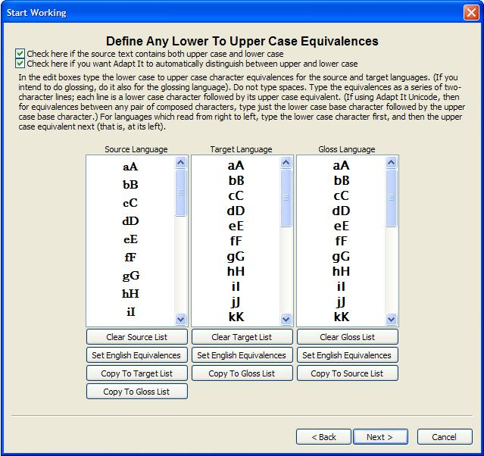
The next page you can probably just accept the defaults and click Next>. You would use the controls on this page if:
- You know the source text markup in the file you intend to load does not use USFM, but the earlier SIL PNG 1998 marker set (the common markers in this set are the same as the equivalent ones in USFM). And / Or:
- You want certain data to not be filtered (i.e. hidden from sight) and so be available for adapting; or you want certain data filtered (such as footnotes) so you don't have to be distracted by having to adapt it while you work at adapting the main text. If you change the setting and want the change to apply to every document you create, change the Project Defaults: part. If you change it for just the Document, the change will apply only to that document and any other documents will revert to the Project setting.
Incidently, the default setting for the filtering of footnotes is to not filter them (meaning, to not hide them). Here is what the USFM and Marker Filtering page looks like. The list of USFM markers is scrolled a little, enough so you can see the footnote entry – you'll notice it is unticked, so any footnotes will not be filtered so as to be hidden from sight when the source text is loaded into Adapt It to create an adaptation document:

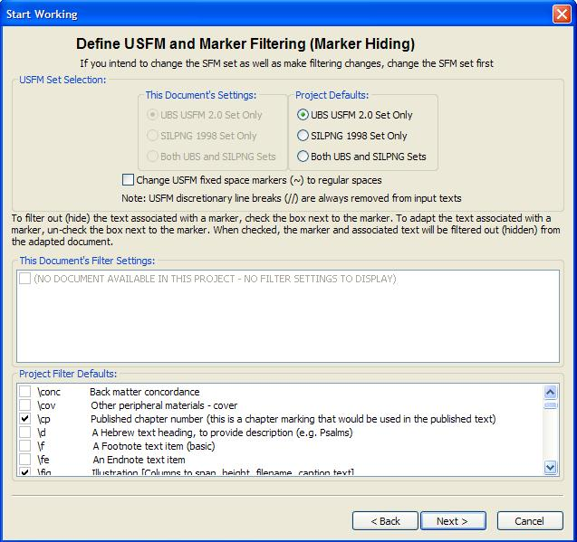

So far you have set up a project, and specified the project name, and the fonts, styles, text sizes and colours to be used in your document. Adapt It has also created an empty knowledge base file for you, given it an appropriate name (for this project it will be "Tok Pisin to English adaptations.xml", stored it in your project folder, and made it ready in memory to receive and store the information about your source words or phrases and what their translations are, as you do your adaptation work later on.

You have also set up the punctuation sets needed for the source and target texts, and the correspondences between individual punctuation characters from each set. You've also set up any upper to lower case correpondences (not all languages have an upper versus lower case distinction). Finally, you've chosen the marker set to be used (for the last decade, everyone has been using USFM – only use the other option if you are sure that USFM is not wanted); and the filtering settings for information in the source text which you don't want to see when you do the adapting work.

You CAN change these settings (use the Edit / Preferences... menu item) at any later time, and if a document is open at the time, the document will be rebuilt with the new settings. It is best though, and safest, to set up your settings for the project just once, and only change them in minor ways. For instance, filtering footnotes might be a good thing to do when you first work on a book; but after completing the adaptation of the book, you might like to go back to its start, unfilter the footnotes, and then do a second pass through the document, just adapting the now visible footnotes. Your settings are remembered in the project's configuration file, so they are back in effect next time you launch Adapt It.

The only thing remaining is to locate a source text file that you wish to adapt, and to create a document for doing the adaptation and storing it on your hard disk. The wizard page below lets you make a new document, or to open an existing one for further work if there are more entries in the list than just the <New Document> entry:

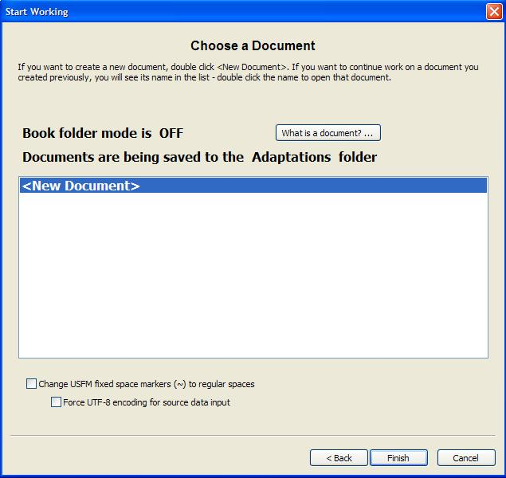

If you do not understand the difference between a document and a project, click the "What is a document? …" button at the top of the dialog, and a window having an explanation of Adapt It documents will open.

You do need to understand the following: Adapt It "New" documents do not start off empty. Since you are going to adapt text from a source language to a target language, an Adapt It document must have the required source language text in it before you can do any adapting. Consequently, when creating a new document, Adapt It will ask you to locate a file containing the source language text you wish to work on.

Make sure your source data is "plain text" (with or without standard format markers.) If you are taking your source text from Paratext, it will be plain text with USFM markup – perfect for what Adapt It expects. Adapt It checks the file before trying to use it, if it appears to be unsuitable for adapting, it will warn you and reject the attempt.

We do not recomment you use the “Bible Book Folders” (Book folder mode) unless an administrator advises you to do so. It adds a bit of complexity you can do without. Therefore we recommend you adapt whole Bible books, rather than splitting a book into several smaller parts, because that will make life easier for you (you will have fewer files to deal with).

A note on standard format markers. Adapt It should work well, even with standard format markers it does not recognize. Unrecognized markers, such as \yy, will be hidden in the normal way, and the navigation text above that location will display the marker between ? symbols,as follows: ?\yy? Those it recognizes are listed and described online at the United Bible Societies' site: http://paratext.ubs-translations.org/usfm – you can also download a free html file from there which desribes the markers and how to use them.

Since you have not made any documents yet, you are about to create your first one; let's do so now:

Step | How to do it | What happens when you do it
- Create a new document. | - if <New Document> is not selected, click on it to select it  - click the Finish button, or instead,  - double-click <New Document > | Adapt It will open a standard Windows file input dialog, provided that an administrator has not pre-configured Adapt It to only show you loadable files from a fixed folder. Otherwise you will just see a list of files from which you can create documents, and you can't navigate to any other folders.  Assuming the standard file dialog is showing, use it to navigate to the "Tok Pisin fragment 1 John.txt" file, and double click I – (or click once to select it and click the OK button). Adapt It will then create the document in memory.

Please note: Adapt It version 6 and later has a hidden Administrator menu which is password protected. You won't be able to open it if you don't know the password. Commands on that menu are dangerous for a user new to using a computer. The menu has options for advanced configuration of Adapt It, including hiding of menu commands unlikely to be needed for the user's current level of expertise. The application, as supplied in the installer, has these advance configuration features turned off, and so if an adminstrator has not pre-configured Adapt It before you use it, you'll see all the commands (except those on the Administrator menu) and be able to navigate anywhere on the computer or on attached drives to locate loadable files for creating adaptation documents. If Adapt It has been preconfigured for you, ask your administrator to take you through this tutorial, or to put the Tok Pisin fragment 1 John.txt file in the Source Data folder for you, so you can create the tutorial adaptation document from it. The basic work procedures described in this tutorial are never turned off, no matter what level of configuration an administrator might set.

When the file dialog closes, Adapt It will put up the following dialog so you can type a name to be used for the output file for the new document. The dialog looks like this:

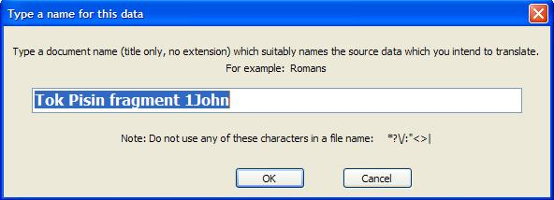

Step | How to do it | What happens when you do it
- Type a document filename | - in the edit box type a name for the output document; for this tutorial you might type  1John fragment  (you can type any name you like)  - click the OK button | Adapt It will take the name you type and add the .xml extension which makes it an Adapt It document filename. The filename would then be:  1John fragment.xml  Whenever the document is saved to the project's Adaptations folder, that is the name which will be used for the filename.

Can you later change the document filename? Certainly, the Save As... command on the File menu will let you do so later on. However, if you want Adapt It to recognize the renamed document you must ensure the following two conditions are satisfied.
- You must leave the filename extension as .xml and
- You must leave the renamed document in the Adaptations folder where it was first saved.
(The Save As... command always ensures these two conditions are met, so if you use that, you know it will work.)

At this point the wizard is finished, and your initial document has been created and is visible on the screen.

Step | How to do it | What happens when you do it
- Resize the main window. | - click in the title bar at the top of the window, and drag it to somewhere near the top left of your screen  - click on the bottom right of the window and drag the window boundary downwards and to the right until the window is the size you want  - or, instead of the above two steps, click on the maximize button at the top right of the window's title bar (it's the button which shows a square in it) and the window will occupy the whole of the screen | The window will be resized according to wherever you drag the mouse while holding down the left mouse button.  You can resize the window at any time while you work, by repeating this step.  You can relocate the window anywhere on your screen anytime, by clicking on and dragging the window's title bar at the very top of the window.

You use the Start Working wizard to create or open a project. You can use it for creating or opening any of your project's documents. However, once you are within your chosen project, you can open an existing document, or create a new document, without using the wizard. Instead you would use File / New to create a new document. Or File / Open to open an existing document. When you use these alternatives, the dialog windows you will see are the same as those you see when using the Start Working wizard.

Chapter 2 Working on a document

Now that you have your first document created and opened, the screen will look something like the following picture. (There may be more or less text showing on each line, depending on the window size you are using and other settings.)

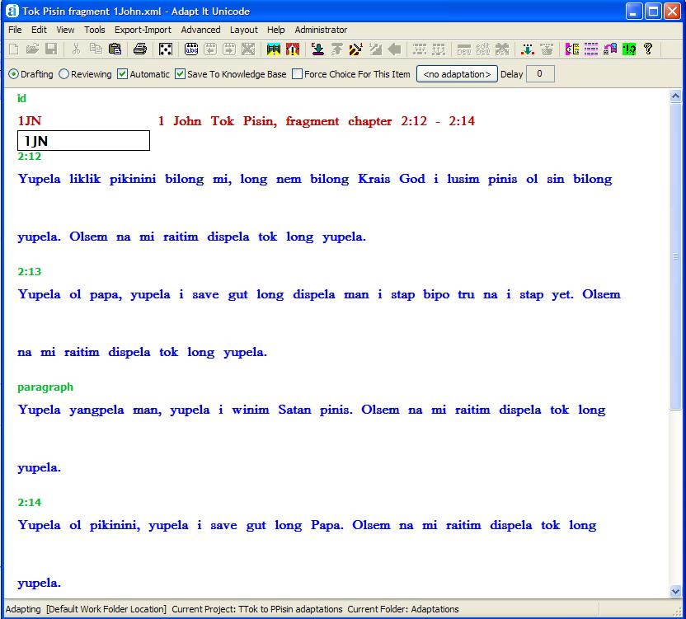

Here is a brief explanation of the things you are looking at in the view of your document. (You don't have to read the explanations below, just skip them if they do not help you and just go straight to the steps you are to do.)
- At the top are the menus. Click on each one, and just have a look at the menu items which are available. Don't worry if some do not make sense to you, you will learn what some of them do later on.
- Below the menus is a row of buttons, this row is called a Toolbar. Each button selects a tool, or does some useful operation. You will learn to use some of these buttons in this chapter. To use a button you click it once with the left mouse button. Some of the buttons can be used by pressing special keys on the keyboard – these special key presses are called "keyboard shortcuts", we will tell you about some of them in this chapter.
- Below the toolbar is a row of checkboxes. You use the mouse to click these, to turn on or off special behaviours. These special behaviours are called "modes". When Adapt It is in a certain "mode", certain behaviours will take place, and other behaviours will not be available until that "mode" is turned off by clicking the checkbox again. Some of these checkboxes are not for modes, but other special effects. We will show you how to use these checkboxes in a later chapter. For now, do not click any of these checkboxes as you work through Chapter 2 of the tutorial.
- Below the checkboxes you can show an additional bar called the "Compose Bar". It is normally hidden, but you can show it by choosing the View menu, and clicking the Compose Bar item. Click that item again to make the Compose Bar be hidden again. The compose bar is where you can type text which you want to keep for a while.
- Then follows the main window. The source text of the input file is shown in blue (because that is the colour we chose), the target language text is black, and navigation text is green - but you can change to other colours if you wish. The text is organized in "strips", the top line of each strip is the (blue) source text, including any punctuation; the second line in each strip is (black) target text, also including punctuation. However, as the picture shows, the only target text so far is 1JN, and it is visible in a box at the top left of the window. This box is called the "Phrase Box", it is where you type your target language adaptations – this box moves to a new location each time you press the ENTER key; and the box will expand or contract as you type into it, or delete text from it. The place where the box is, at any point of time, is called the "active location". Currently, the active location is at the very first word of the input file.
- As you work, typing adaptations for source words or phrases, your adaptations will become visible under the source words. We are ready to do some adapting now, so let's go to our first exercise.

Adapting a single source word

We want to adapt the word "Yupela" at the start of chapter 2, verse 12. The active location is not there, so before we do this exercise let us first get the phrase box to appear underneath the word "Yupela". Hit the ENTER key several times – notice what happens each time; stop when the phrase box is underneath "Yupela".

Exercise 2.1 Adapting "Yupela" (which means "you" – referring to more than one person), by giving it the meaning "You". (Note: in these exercises, text you are to type will often be shown between quote marks (" … "). Do not type the quote marks, just type whatever is between the quote marks.)

Step | How to do it | What happens when you do it
- Adapt "Yupela" | - in the phrase box, if "Yupela" is not already selected, then select it  - type "You"  - Press the ENTER key | (You can select a word either by double-clicking it; or by clicking at one end and while holding the left mouse button down drag the cursor to the other end of the word.)  When you press ENTER, an entry is made in the knowledge base, and the phrase box jumps to the next "empty" location, and Adapt It copies the source word at that location and puts it in the phrase box for you, in case the adaptation for it is spelled the same way.

Extra Practice
Adapt the following two words in the same way.
The word "liklik" means "little". Type "little" in the phrase box and then hit the ENTER key.
The word "pikinini" means either "child" or "children". When you adapt it, use the meaning "children".
When you have finished those two source words, the phrase box will be underneath the word "bilong".

Merging source words to make a source phrase (the quick way)

The following explanation might help you understand how Adapt It stores its information, and why the next exercise is needed. You can skip the explanation if you wish, but this operation is probably the most important one in all of Adapt It's features, so it may be worth your while to understand what is happening.

Sometimes you will not want to translate each source word with a single target word, or target phrase. Sometimes you will want to combine, or "merge" several source words into a single phrase, and then type an adaptation for that source phrase. The most likely times you would want to do this are:
- when adapting each individual source word would not result in a natural sounding translation, or
- the order of the words in the adaptation needs to be different from the order of the words in the source text.

The source words are stored in document storage elements, and the storage elements are arranged in the strips one after another from left to right. Each storage element stores the source text and its target text adaptation, as well as other information. The source and target text is arranged on your screen, for each storage element, in a "pile" – that is, one piece of text piled on top of another; for example, "Yupela" and the adaptation "You" are in a single pile. When your document is created from the input file you specified, Adapt It "cuts up" the input text into a series of single words, and stores each single word in a single storage element, and each such storage element is shown on the screen as a single pile. Here is a diagram of how the piles are arranged in a strip containing 15 piles, as shown on the screen.

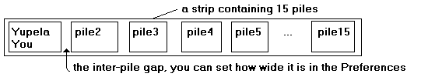
If each pile shows just a single source word, then you need a way to cause Adapt It to take two or more source words and combine the words into a single phrase, stored on a single storage element – and therefore displayed on the screen in a single pile.

This operation of combining source words into a phrase is what we are going to do next. We want the two words "bilong" (meaning "of") and "mi" (meaning "I" or "me" or "mine") to be combined into the phrase "bilong mi"; and then we want to give this phrase the adaptation "of mine". We also want the knowledge base entry for this adaptation to be stored with all the other 2-word phrases – this will be accomplished automatically by merging the single words on the two piles into a single phrase containing the two source words.

Exercise 2.2 Merging two words to form a 2-word source phrase.

To do a merge operation, Adapt It needs to first know how many words have to be combined, and which ones are involved. The application gets this information by you selecting the words you want to be merged into a phrase. So we have to learn how to make a selection. There are several ways to do this. The way we will show you now is probably the most useful one, because it is easy to do and your hands do not need to leave the keyboard. You will be using an
ALT + right arrow key combination to do the selecting. Then for the merging, you can either just type your adaptation, or use the ALT+ENTER key combination as a shortcut to make the merge happen without typing, and then do the typing after that. We will show you other ways later on. Most people would probably prefer to cause the merge to happen by just typing after getting the required selection. That is the easiest way to do it.

Step | How to do it | What happens when you do it
- Merge the source word "bilong" and the next word "mi" to form a source phrase "bilong mi". | - make sure the cursor is in the phrase box somewhere, if not, click in the box somewhere (and make sure the box is below the word "bilong" – if it isn't, click in the white space under "bilong" and the box will be placed there  - hold down the ALT key  - with your other hand, press the right arrow key once only  - (optional step which can be omitted) keeping your hand on the ALT key, press the ENTER key  - type the adaptation "of mine" (if you omited the previous step, as soon as you type the "o" of the word "of" the merge happens)  - press the ENTER key to go to the next empty pile | One press of the right arrow key selects the source word at the active location, plus the next source word to its right; so "bilong" and "mi" will both be selected. Selections have a yellow background.  When you press the ENTER key with the ALT key also held down, any words in a selection get merged into a source phrase (and if they have existing adaptations, the adaptation words will be added together to form a potential adaptation for the new phrase, and will be shown in the phrase box)  The final press of the ENTER key stores the phrase and its adaptation in the knowledge base

Note: if you intend to type a translation in the phrase box after the merge is done, you can skip the third-last step (that is, do not bother to press the ALT+ENTER key combination), and instead just start typing the adaptation text "of mine". Whenever you type something into the phrase box while the phrase box is a part of a selection, Adapt It will assume you intend a merge to take place first, and so it will merge the source words before it shows you the first character of your typing.

Unmerging a source phrase

If you want to separate the words of a merged source phrase into a sequence of single words, each shown in its own pile, there is a button for this purpose. There is also a keyboard shortcut, the SHIFT+END key combination (that is, hold down the SHIFT key while pressing the End key).

In this exercise we will unmerge the phrase "bilong mi" which we made in section 2.3. Then in section 2.4 we will make the same phrase again, but in a different way.

Exercise 2.3. Unmerging "bilong mi"

This can be done in two slightly different ways, depending on the location of the phrase box. The most general way uses a selection, so it does not matter where the phrase box happens to be, since Adapt It will know which phrase to unmerge by the location of the selection. We will do that way first.

Step | How to do it | What happens when you do it
- Unmerge the source phrase "bilong mi"  (Method one: using a selection) | - it does not matter where the phrase box is, so leave it under the source word "long"  - select by clicking on the source phrase to be unmerged (that is, click on "bilong mi")  - click the Unmerge button (or type the keyboard shortcut SHIFT+END) | The phrase becomes two separate words again.  The knowledge base is adjusted appropriately (ie. the old phrase entry is removed, in this case)  The phrase box is placed at the first of the unmerged words, making that the new active location.  Adapt It will try to put the most sensible text possible in the box for you, so it will look up the knowledge base and try to find a suitable adaptation for the first source word. If it cannot find something suitable, it will just show the old translation of the source phrase you have just unmerged, which you will then probably need to edit manually.

The second method for doing this does not use a selection. But this method requires the phrase box to be located underneath the source phrase you want to unmerge. If there is no selection, Adapt It looks for a phrase at the active location, and if it finds one there, it will unmerge it when you give the command to unmerge.

Step | How to do it | What happens when you do it
- Unmerge the source phrase "bilong mi"  (Method two: using the active location rather than a selection) | - the phrase box has to be under the source phrase "bilong mi"; it currently isn't there, so click the translation "of mine" and the phrase box will be put there. (It would be a good idea to delete the word "long" in the phrase box first, so that it does not get stored as an adaptation.)  - click the Unmerge button (or type the keyboard shortcut SHIFT+END) | The phrase becomes two separate words again.  The knowledge base is adjusted appropriately (ie. the old phrase entry is removed, in this case)  The phrase box is placed at the first of the unmerged words, making that the new active location.  Adapt It will try to put the most sensible text possible in the box for you, so it will look up the knowledge base and try to find a suitable adaptation for the first source word. If it cannot find something suitable, it will just show the old translation of the source phrase you have just unmerged, which you will then probably need to edit manually.

Merging source words to make a source phrase (two other ways)

Now we will merge "bilong" and "mi" again, using two different ways. These can be used regardless of where the active location might happen to be. You make a selection, but in a different way than in section 2.2; and the selection can be distant from the active location.

The phrase box can be anywhere for these exercises.

Step | How to do it | What happens when you do it
- Merge the source word "bilong" and the next word "mi" to form the source phrase "bilong mi"  (By clicking once to start a selection and then extending the selection) | - the phrase box can be anywhere, or it can be under the word "bilong" or under "mi", it doesn't matter  - click the source word "bilong" once to select it  - extend the selection by holding down the SHIFT key while clicking on the word "mi"  - type the adaptation, which for this source phrase is "of mine"  - press the ENTER key to go to the next empty location | The two separate words become a phrase.  The phrase box is placed under the merged source phrase, making that the new active location.  The phrase box will show a guess for the adaptation, and it will be selected. When you type "of mine" it replaces the selection with your typing.  When the phrase box moves on to a new location the knowledge base is adjusted appropriately (ie. in this case a "bilong mi" phrase entry is added, plus its adaptation "of mine")

In the above exercise, notice that you skipped pressing the merge button, and just instead typed the phrase "of mine". Notice that the merge still took place and your typing appeared in the phrase box.

A third way to form a selection is by clicking and dragging. Let's do the preceding exercise again, using this method. First, unmerge the phrase, and then do this exercise.

Step | How to do it | What happens when you do it
- Merge the source word "bilong" and the next word "mi" to form the source phrase "bilong mi"  (By clicking and dragging to extend the selection) | - the phrase box can be anywhere, or it can be under the word "bilong" or under "mi", it doesn't matter  - click the source word "bilong" once to select it, keep the mouse button down while you  - extend the selection by dragging the cursor until it points within the word "mi", then release the mouse button  - type the adaptation, which for this source phrase is "of mine"  - press the ENTER key to go to the next empty location | The two separate words become a phrase.  The phrase box is placed under the merged source phrase, making that the new active location.  The phrase box will show a guess for the adaptation, and it will be selected. When you type "of mine" it replaces the selection with your typing.  When the phrase box moves on to a new location the knowledge base is adjusted appropriately (ie. in this case a "bilong mi" phrase entry is added, plus its adaptation "of mine")

2.5 Practice merging words

Exercise 2.5 Merge the words "long" (a preposition which can have many meanings such as in, on, over, to, from, etc.), "nem" (meaning "name"), "bilong" (meaning "of") and "Krais" (meaning "Christ").

Step | How to do it | What happens when you do it
- Merge the next four words into a 4-word source phrase. Give it the adaptation "in the name of Christ". | - the phrase box can be anywhere  - click on the source word "long"  - extend the selection by holding down the SHIFT key while clicking on the word "Krais"  - click the merge button (or you instead can use the ALT+ENTER key combination discussed in 2.2)  - type the adaptation, which for this source phrase is "in the name of Christ"  - press the ENTER key to go to the next empty location | The four separate words become a phrase.  The phrase box is placed under the merged source phrase, making that the new active location.  The phrase box will show a guess for the adaptation, and it will be selected. When you type "in the name of Christ" it replaces the selection with your typing.  When the phrase box moves on to a new location the knowledge base is adjusted appropriately (ie. in this case a "long nem bilong Krais" phrase entry is added, plus its adaptation "in the name of Christ")

2.6 Accepting a default adaptation without changes

The phrase box will now be under the source word "God", and the default adaptation (copied from the source text) shown in the box will also be the word "God", and it is selected. Since the adaptation text is already what we want, we will accept it without changes.

Here is an explanation of the word "default", if you are not familiar with it.
Default text is text which Adapt It supplies when it cannot find something better. For example, Adapt It will try find an adaptation for a source word in the knowledge base; but if it cannot find something suitable, then it will instead make some default text to put in the phrase box instead. It makes the default text by taking the source word, doing any consistent changes you require (if you have consistent changes turn on), and then showing the result in the phrase box.
So "default" text is the text you get when every other avenue for getting some suitable text has failed.

Step | How to do it | What happens when you do it
- Accept a default adaptation supplied by Adapt It in the phrase box, without making changes. | - press the ENTER key to go to the next empty location | The phrase box is placed under the next source word having no adaptation yet, making that the new active location.  The phrase box will show default adaptation text constructed by copying the source word at the new active location. In this case the default text will be "i"

2.7 Retranslating a section of source text

Sometimes you may wish not to adapt a certain section of the source text. Instead, you would like to make a new translatiaon for that part of the text. You might want to do this if you think the meaning of the original translation (the source text) is not very accurate in that section; or perhaps the order of the words in the target text needs to be very different than the word order in the source text.

Exercise 2.7 Retranslate the section of source text "i lusim pinis ol sin bilong yupela". A literal translation of this section would read: "he released already sins of you". But that is not quite the meaning we want in English, and some words are hard to express in English, such as "i" which indicates that a verb follows, and "pinis" which indicates that an action has been completed. So this section is a good one to retranslate so that we can make the translation sound natural in English.

Step | How to do it | What happens when you do it
- Retranslate a section of source text. | - click on the word "i" and keeping the mouse button down drag the mouse to point at "yupela" so that all the words "i lusim pinis ol sin bilong yupela" become selected. (The cursor does not have to touch each intervening word as you drag, it just needs to end up pointing to the last word of your intended selection.)  - click the "Do a Retranslation" button to open the retranslation dialog (or you can use the ALT + up arrow key combination as a shortcut; or the F9 function key as a shortcut.  - In the dialog's text box, type the new translation:  "has taken away all of your sins." (Remember to include the punctuation at the end.)  - Click the OK button to close the dialog. | The selected source text appears in the dialog; also shown in the dialog is the surrounding context – text which precedes the selection is a the top, and text which follows the selection is at the bottom. (A button allows you to switch to target text for the context, or back again to source text.)  You use the retranslation box to type your new text. (You may have to delete what it is in it first.)  When you close the dialog with the OK button, your new translation is laid out under the selected source words; extra piles are inserted automatically at the end if your new translation is longer than the source text. These each contain a "null source phrase", and their source text is just three dots (…). If your translation is shorter than the original selection, then some of the source words will have nothing under them. In the present case, source and target text are the same length.  Notice that your retranslation has #* above it to show where it starts. Also, each word has * above it. The * means that this text is not stored in the knowledge base. Retranslations never go into the knowledge base.  If you have chosen a unique colour for retranslation text, it will have that colour.

This tutorial will not discuss the buttons in the retranslation dialog. If you want to know more about what those buttons do, they are discussed fully in the "Adapt It Basics.doc" reference document, on pages 19-20. Click the buttons, it will not do any harm, to see their effects.

2.8 Retranslating a long section of source text

Retranslating a large section of text is similar to retranslating just a few words, but there is a potential problem which requires an extra step.

When you try to select a large section to be retranslated, if there is some punctuation in that section you will find that your attempt to select everything will stop short, in fact, it will stop at the first punctuation character Adapt It finds (but it does not stop at commas). The reason the selection stops at the punctuation is because there is a hidden boundary there. The boundary is put there automatically when the document was first created; it is there in order to protect you from making merges of several words into phrases which are unlikely to be grammatically sensible choices. However, these boundaries are a nuisance when you want to retranslate a large section of text. Fortunately, there is a button you can press which will instruct Adapt It to temporarily ignore all boundaries – then you will be able to make a selection be as long as you like.
You can demonstrate the problem exists in the following way:
- Click on the source text word "Olsem" to select it
- Hold down the SHIFT key and then click on the source text word "yupela." at the end of VERSE 13 (not the one at the end of verse 12, but the one later still – at the end of verse 13)

Notice that the words were selected only up to the end of verse 12. That is because there is a period (.) after the word yupela, and so there is a boundary there. In the exercise below, we will show you how to make the selection cross this punctuation boundary with just a click of a button.

Exercise 2.8 Retranslating a long section of source text, from "Olsem" in 1 John 2:12 to "yupela" at the end of 2:13.

This requires just one extra step, otherwise it is just the same as exercise 2.7.

Step | How to do it | What happens when you do it
- Retranslate a long section of source text, which spans punctuation breaks (other than comma). | - click on "Olsem" to select it  - click on the "Respect Boundaries" button to toggle its setting so that it looks as follows:  - hold down the SHIFT key and click on "yupela" at the end of verse 13  - click the "Do a Retranslation" button to open the retranslation dialog (or you can use the ALT + up arrow key combination as a shortcut)  - In the dialog's text box, type the new translation:  " So I am writing this letter to you. You fathers, you know well the man who lived long ago and who still lives. So I am writing this letter to you."  (Remember to include the punctuation.)  - Click the OK button to close the dialog. | We changed the selection method for this exercise. For a long selection, it is much quicker to click at one end of the intended selection, then hold the SHIFT key down and click at the other end.  The extra step was the click on the button. This switches Adapt It to an "ignore punctuation boundaries" state, making it able to select across punctuation breaks – at least while the phrase box remains at the current location. (Adapt It will automatically restore the earlier state once the phrase box moves elsewhere from its current location.)  Adapt It lays out the long retranslation. It has fewer words than the Tok Pisin, so some of the source words at the end do not have any of the retranslation under them.  The phrase box is placed at the first available location after the retranslated section.

It is also possible to have boundaries ignored when you make a long selection using the click and drag method. Just hold down the CTRL key while you do the drag.

2.9 Removing a retranslation

It is very easy to get rid of a retranslation. When you remove it, the piles will show a single source word on each pile. The old retranslation may appear to have been completely lost, but that is not so. It will be preserved in the Compose Bar, and it will stay there until you change the contents of the Compose Bar. The Compose Bar is normally hidden, we will show you have to make it visible as part of this exercise.

Exercise 2.9 Remove the long retranslation we made in exercise 2.8.

Step | How to do it | What happens when you do it
- Remove the retranslation we made in the previous exercise | - Click to select any source word in the retranslation, it does not matter which one (it also does not matter where the phrase box currently is)  - Click the "Remove A Retranslation" button | Adapt It will remove the old retranslation, and restore the phrase box to the first empty location in the place where the retranslation used to be.
- Display the Compose Bar (only if you want to access the old retranslation text) | - Click on the View menu, and click the Compose Bar menu item | A new toolbar appears above the main window. In the text box you will see the old retranslation text. You can do anything you like with it: e.g. cut and paste parts of it somewhere, or delete it (the Clear Contents button is a quick way to do that), or select all of it using the Select All button, or ignore it, etc.
- Hide the Compose Bar. | - Click on the View menu, and click again the Compose Bar menu item | The Compose Bar will be hidden. If you hid it with text in the text box, the text will remain there – at least until you later on remove a different retranslation, or do some other operation which changes the contents of the text box.

2.10 Editing a retranslation

You can edit an existing retranslation at any time; shortening it, or lengthening it as you please. Adapt It will lay out the display of the document again, taking account of your changes.

Exercise 2.10 Edit the retranslation at the middle of 2:12.

Looking at the first retranslation we did, we may feel that we want to remove the word "of", so that it will read "has taken away all your sins." That sounds a little better in English.

Step | How to do it | What happens when you do it
- Edit the retranslation "has taken away all of your sins." | - Click on any source word in the retranslation, so it is selected  - Click the "Edit A Retranslation" button to open the retranslation dialog for editing  - In the dialog's text box, make the editing changes you require. In this case, remove the word "of" and a space.  - Click the OK button to close the dialog. | The retranslation is displayed again, but with the target text showing the edited form.

2.11 Inserting an extra word or phrase

Sometimes your adapted text does not quite sound right unless you add an extra word or phrase somewhere. The problem with adding the extra information to an already existing translation of a source word or phrase is that Adapt It may later try to insert that extra information at some other place where it does not belong. What you need is some kind of "place holder" in the source text which allows you to insert an extra word or phrase in the target text. There is a button for this purpose, we will use it in this exercise.

To prepare, look at chapter 2 verse 13; click underneath the word "long", and then using what you have learned earlier merge the words "long dispela man" into a phrase and give it the translation "about this man". Press the ENTER key, and then merge the two words "i stap" into a phrase and give it the translation "existed", press the ENTER key. Now we are ready. Notice, the English does not read well at all: "about this man existed" is certainly not good English. What we need is the word "who" preceding the word "existed". We don't want the "who" to be part of the meaning for "i stap" because sometimes "i stap" will just mean "existed" without any preceding "who". The solution is to insert the word between the two phrases you just made.

Exercise 2.11 Inserting the word "who" preceding a pile.

Step | How to do it | What happens when you do it
- Insert "who" before "existed" | - The phrase box can be anywhere provided we use a selection - so select the phrase "i stap"  - Click the "Insert A Null Source Phrase" button to get the placeholder inserted into the source text and the phrase box moved there ready for your typing.  (If you hold the CTRL key down when you click, the insertion will be done AFTER the selection, or after the active location if there is no selection.)  - Type the word "who"  - Press the ENTER key to move to the next empty location. | Selecting "i stap" tells Adapt It where it is to insert the placeholder - it will be inserted immediately preceding the selected pile. (If you did not use a selection, the placeholder would, by default, be put immediately preceding the current active location - that is, where the phrase box currently is located.)  The knowledge base saves your entry, but these never get later inserted in the text automatically, because no … elipsis exists beforehand.  Read the note below for some special behaviour.

When you insert a placeholder at a location in the source text where there is punctuation (either punctuation at the end of the preceding context - for example, a period at the end of a sentence, or punctuation at the start of the following context - for example, opening quotation marks, or both), Adapt It will show you a message asking you how it is to associate the newly typed text with the surrounding context. You can associate it to the left, so that it is considered part of the preceding context; or to the right, so that it becomes part of the following context. Depending on your answer, Adapt It will then move the appropriate punctuation to the proper place. (If you delete a null source phrase, punctuation which has been moved will be automatically moved back where it originally was.)

You can try this out by selecting the word "Olsem", choosing the "Insert A Null Source Phrase" button, and then when the message dialog comes up, click the No button to cause the association to be to the left. Then type a word, hit ENTER, and then observe where Adapt It places the period. It will be put after the inserted word that you typed. Then get rid of the inserted word - how to do that is the subject of the next section. Note: using the button or the shortcut while holding down the CTRL key, results in an insertion AFTER the relevant location, instead of BEFORE it.

2.12 Removing an inserted extra word or phrase

Exercise 2.12 Removing an unwanted insertion.

First make an insertion somewhere (see section 2.11).

Step | How to do it | What happens when you do it
- Remove a null source phrase which is no longer wanted. | - If the phrase box is not under the … elipsis, then you need to tell Adapt It which null source phrase to remove by clicking the … elipsis text to select it. (If the phrase box is already under it, no selection is needed.)  - Click the "Remove A Null Source Phrase" button to get the placeholder removed.  - Press the ENTER key to move to the next empty location, or click a target text translation somewhere to have the phrase box placed there. | When the ellipsis is removed, the target text which was under it is deleted from the document at that location, and its entry in the knowledge base is removed.  If Adapt It earlier moved punctuation to the start of end of the inserted target text, when the removal takes place, the puctuation is automatically moved back to where it would be had the insertion never been done.

Reading your translation without the source text being shown

This is accomplished by a button. It is a "toggle" - each click changes the view to the opposite state. The "target text only" view is useful for reading through your work without the distraction of the source text and the more cluttered window appearance.

Step | How to do it | What happens when you do it
- Read just the target text.  - Restore the view showing both source and target text. | - Click the "Show Target Text Only" button  - Click the "Show Source And Target Text" button | When the button is clicked, the view changes to show only the target text. You can still edit the translation, you can move the phrase box by clicking on any word or phase, and so forth. In fact, any operation that makes sense in this view is permitted; those which cannot be done (such as those requiring a selection be made first) are temporarily disabled. You can also print this view, or the normal view.  Clicking the button again (it has a new appearance) restores the normal view again.

Single Step mode versus Automatic mode

So far you have been working in Automatic mode. On the left of the toolbar above the main window you will see a checkbox called "Automatic" and it will be checked. If you click this checkbox, it will become unchecked and the mode will shift to Single Step mode.

In Single Step mode, Adapt It works like this: when you press the ENTER key, the application looks for the next empty location. After finding it, it then "looks ahead" at the next 10 source words - checking in the knowledge base for a matching phrase, and if it finds one, it will merge the words into a 10-word phrase, supply the translation which you gave ealier for that phrase, and then stop and wait for you to do something. If it could not find a 10 word source phrase at that location, it shortens the test to 9 words, merging and adding the translation if it finds a match in the knowledge base and providing the translation is unique. Failing to find a 9 word phrase it tries 8, failing that it tries 7, and so on until it tries to match just the single word at the new location. If nothing matches in the knowledge base, then it copies the source word to the phrase box as the default translation, and then waits for you to do something. If the application finds a matching source phrase in the knowledge base, but that phrase has two or more possible translations, then it puts up a Choose Translation dialog (discussed later) for you to choose which translation you want, or to type a new one.

In Automatic mode (the default mode) all of the above happen except that Adapt It no longer waits after it inserts a translation having found a match for the phrase (or word) at the new location; instead, it goes on to the next empty location and repeats the procedure - continuing indefinitely in this way until one of the following two things happen:
- multiple translations are possible for a matched source phrase, so the Choose Translation dialog is put up and processing halts while you interact with the dialog; or
- nothing in the knowledge base is matched, so processing halts for you to type a translation for the unknown word or phrase which has been encountered in the source text.

Multiple translations - the Choose Translation dialog

The insertion of a pre-existing translation takes place only when that translation is unique. If you have previously given a single source word (or source phrase) two or more different translations, Adapt It cannot decide for you which is the one required at a new location. So it asks you to supply the correct one by putting up the following dialog:

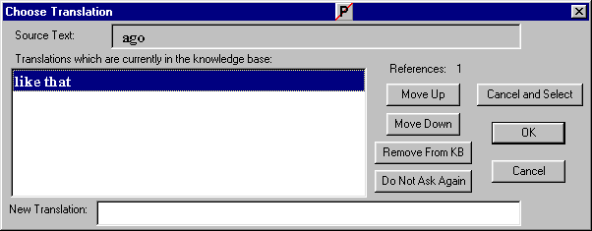

This dialog is discussed fully in the Adapt It Basics documentation, see there for details. Briefly, to choose a translation listed in the box on the left, just double-click it; if none of the translations is suitable for the current active location, then type a new translation in the editbox at the bottom, and then press the OK button. Clicking the OK button will close the dialog and cause whichever translation is selected to be inserted in the phrase box. You can use the Move Up or Move Down buttons to reorder the translations in the list so that the most commonly wanted one occurs first. You can also remove an unwanted translation from the knowledge base using the Remove From KB button. (It removes the entry from the knowledge base, but does not remove instances of that translation in your documents - to do the latter, you would need to do a Consistency Check, - see the Adapt It Quick Start document for how to do that.)

It is possible to force the Choose Translation dialog to be shown at any location. Just click to place the phrase box at the desired location, and then click the "Show The Choose Translation Dialog" button , or click the F8 function key which is a shortcut.

If you want to see Adapt It handle multiple translations, do the following exercise. The exercise assumes that you have translated the first instance of the word "Yupela" as "You".

Step | How to do it | What happens when you do it
- Observing Adapt It's behaviour when there are multiple translation possibilities. | - The sentence at the start of verse 13 begins with "Yupela". Click under this word to put the phrase box there, then type "You all" as its translation.  - Press the ENTER button.  - Click under the last word of verse 13 (which is "yupela" with a lower case y); type something there - perhaps "you" would be good.  - Press the ENTER button, and the Choose Translation dialog will appear showing the two translations for "Yupela" which are currently known: "You" and "You all".  - Double-click one of the translations, and it will be inserted into the phrase box, and the dialog will be closed automatically. | Whenever a source word, or source phrase has two or more existing translations stored in the knowledge base, only the human being using the application knows which one is the correct translation at any given place in the text. So Adapt It will always show this dialog to you whenever it cannot decide which translation is correct.

Note: on the toolbar there is a checkbox called "Force Choice For This Item". If you click that checkbox to ON after typing a translation, and before you hit the ENTER key, then even if the translation is unique the next time Adapt It encounters the same source text it will show the Choose Translation dialog. You would do this when translating a word of phrase for the first time, but you know that later on the word or phrase is going to have other meanings that you will need to type, so you don't want Adapt It to keep inserting the first meaning you typed every time it comes to the same word or phrase. You want to force Adapt It to give you the chance to type a second meaning when the same source word is next encountered - that's what the checkbox is for. (Turning the checkbox ON sets a flag in the knowledge base entry for this translation; you can unset the flag if you wish, either in the Choose Translation dialog, or in the Knowledge Base Editor, by using the button for that purpose.)

Placing the Phrase Box at an arbitrary location

When you press the ENTER key, the phrase box moves forward. Sometimes you may want to move back, or place the box at some translation you made earlier and now wish to edit. To do so, just click the translation you want the phrase box to be located at. It will then move there. When the phrase box moves, the translation at the earlier location is then automatically added to the knowledge base. If you wish to place the phrase box at an "empty" location, just click immediately underneath the source word at that location. (The knowledge base "look up" procedure is also attempted automatically whenever the clicked location is empty, so if there is a translation for that source word or phrase in the knowledge base, it would be inserted for you automatically - same as what happens when you press the ENTER key.)

Three kinds of "nothing"

Quite often you will want to leave a source word untranslated. There are three ways you can do this. The first way is easy, but not recommended. The second way is the one you should use in most situations, it gives you behaviours which are more flexible. The third way is a little more general – the translation can be either nothing, or something, but you know that you don't want any of these translations stored in the knowledge base. Let's consider these 3 ways now.

Way 1.
Just press the Backspace key, or the Del key, to delete the target text in the phrase box. Then press the ENTER key. The source word will have no translation, nothing will appear under it, and nothing will be entered in the knowledge base. One unfortunate result, however, is that if you one day have the phrase box at an earlier place in the document, and you press ENTER, the box will stop at this location (although you probably don't want it to) and copy the source text there again, and you will be left guessing why it stopped there and whether or not the text you see in the box should really be there. Then you will have to read the meaning all over again, and delete the translation text again. Clearly this is not what you want to do, so do not use this kind of way for having no translation.

Way 2.
Click the toolbar button called <no adaptation> and the box will then be cleared, and an empty entry will be inserted automatically and instantly in the knowledge base (before you hit the ENTER key). If you look in the knowledge base you will see the "meaning" is shown as <no adaptation>. This is just for your convenience; under the hood, Adapt It has actually stored an empty translation. In the main window you will see that the translation is nothing at all. There are two benefits to using this kind of "nothing." First, if you press ENTER when the phrase box is at an earlier location, this location will be skipped by the phrase box when it moves - which is probably what you want to happen. Secondly, this kind of nothing can co-exist with actual translated words or phrases in the knowledge base; so the source word (or phrase) could be translated by something in one place, and by nothing in another place. When Adapt It comes across the source word (or phrase) again, it would then show you the Choose Translation dialog, and one of the entries would be <no adaptation>, and you can choose which one you want in the normal way.

Using the <no adaptation> button is, for most situations, most likely to give you the behaviours you would want. It does not limit you in any way, and it causes the phrase box to skip such locations. And if the <no adaptation> entry is the only one for that source word or phrase, it will automatically be inserted for you in other places, just like any other translation.

Way 3.
(From version 1.4.0 and onwards, this option has a slightly different behaviour.) Click the toolbar checkbox "Save To Knowledge Base" to turn if off. (It stays off only while at the current active location.) This will force a special entry, <Not In KB>, to be put in the knowledge base. This special entry tells Adapt It that this source word will NEVER have a translation stored in the knowledge base. It will allow you to add a translation for that source word at that location in the document, it just won't get stored in the knowledge base. The phrase box will never stop there when it is located earlier in the document and you then press the ENTER key. So when it comes to that location it will just continue moving on - whether there is an adaptation at that place in the document or nothing at all.

When Adapt It is looking ahead, in Automatic mode, after you press the ENTER key, every time it finds that same source word (or phrase) it will continue to treat it as having no stored adaptation in the knowledge base, and so it will just insert nothing as a default adaptation and move on – so in the main window you see nothing at that location, except for the expected asterisk above it, which reminds you that that word or phrase has no meaningful entry in the knowledge base. You are free to later click on any of these empty locations to put the phrase box there, and you can type some adaptation text there – but the new adaptation text just won't be stored in the knowledge base when you move the phrase box to some other location by clicking, or by pressing ENTER or TAB or SHIFT+TAB. So as long as the asterisk shows above that source word or phrase, whatever adaptation is there is there only in the document; the knowledge base will know nothing about it.

If you want to make this kind of "nothing" into one of the other kinds of "nothing", or if there is adapted text there and you want to make it be stored in the knowledge base, just place the phrase box there and then click the Save To Knowledge Base checkbox again, and you will then get the normal behaviour because you will have restored the normal state (even though the asterisk still shows, it won't be there any longer as soon as the box moves somewhere else.)

Use this kind of "nothing" when you are certain a word or phrase should never be translated; or when you want to give a different translation each time you encounter this particular source text and you don't want any of those translations stored in the knowledge base.

Other operations

The preceding tutorial gives you enough for you to begin doing real work. Some topics have not been treated, but you can find out about them either in the "Adapt It Quick Start" document, or in the "Adapt It Basics" reference documentation.

Remember, when your document is long, it is not all shown at the one time. Adapt It "cuts up" the document into small working-sized chunks; and the scroll bars only scroll within a single chunk. There are toolbar buttons, "Step Up", "Step Down", "To Start", and "To End" which enable you to move to the next or previous chunk, or to the start or end of the document; and if you are working at adapting, the movement to the next chunk is automatic and you will probably not even notice it happening. If your document contains \c and \v markers for chapter and verse, then you can also navigate using the Go To… command on the Edit menu.

Note that "under the hood" Adapt It maintains four lines per strip. Normally only two are shown; but you can switch to 3 or 4 line display using the buttons for that purpose on the toolbar. Find and Replace operations automatically switch the display to 4 lines, and after using those commands the application will automatically switch back to the normal 2-lines per strip display, or to however many lines you were formerly displaying.

Finally, on the Tools menu, you will see a "Knowledge Base Editor" command. You can inspect the knowledge base using this command. The dialog it puts up has 10 tabs, one for each phrase length, to simplify finding things. Read more about this editor in the above more detailed documentation files. You can also edit the source text if you wish – there is a command for doing that in the Edit menu, and then you can also fiddle with the standard format markers in your source text data safely, if you feel you need to do that.

And don't forget the Export commands on the File menu. Use these to get text files of either your edited source text, or the current translation text, or the current contents of the knowledge base. In the latter case, this is another good way to safeguard your knowledge bases; because you can always Import the exported data back into the same, or a different knowledge base. Using the Import and Export knowledge base commands together can allow all the members of a team, each using a computer to adapt a different book, to share their knowledge bases on floppy disks, each person Importing each of the other Exported knowledge bases - so that everyone benefits from everyone else's work by having knowledge bases which "know" everything done by each of the other team members.

Hope you like Adapt It. Bruce Waters

